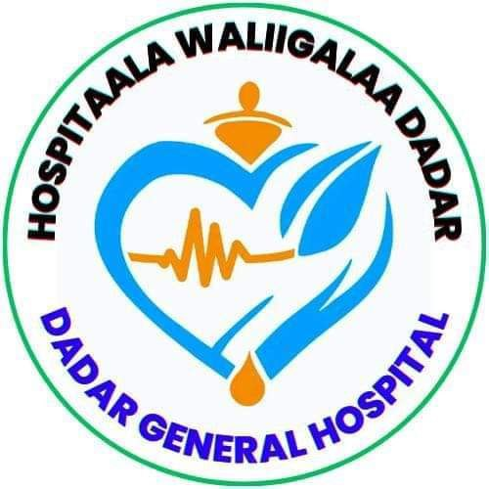

DEDER GENERAL HOSPITAL
Hand Hygiene Compliance Assessment Report

Report period: 2nd Quarter of 2017EFY

Conducted By: IPC Committee

December 2017E.C
Deder, Oromia

IPC Committee Member
No | Name | Position | Role
 | Dr. Derese Gosa | Medical Director | Chairperson
 | Hamza Jemal | Head Nurse/Matron | Vice Chairperson
 | Abdi Tofik | Quality & Safety Unit head | Member
 | Addisu Wondimu | OR/Obs/Gyn Head | Member
 | Alamudin Usmail | Laboratory Head | Member
 | Jafer Dine | TB Clinic Head | Member
 | Kalifa Jemal | Surgical Ward head | Member
 | Chala Abdusalam | Pediatrics Head | Member
 | Balisa usmail | Pharmacy Head | Member
 | Obsa Usmail | Finance and Property head | Member
 | Nure Jemal | Maintenance Officer | Member
 | Kadir hasen sali | Laundry Service head | Member
 | Desta Tafesa | Cleaner Head | Member

TABLE OF CONTENTS
Introduction 1
Purpose 2
Scope 2
Methodology. 2
Results 3
1. hand hygiene Compliance Assessment results per Ward/Unit 3
2. According to Professional categories. 8
3. Compliance according to Ward/Unit 9
4. HH Compliance According to Indications 10
5. Deder General Hospital Overall Hand Hygiene compliance rate 12
Recommendations/Interventions. 14

LISTS OF TABLE AND FIGURES
Table 1: Action plan to improve hand hygiene compliance, 2017E.C 20
Table 2: Implementation Progress Report: Hand Hygiene Improvement Action Plan (Status as of December 2017E.C) 21

Figure 1: Deder General Hospital Hand Hygiene Compliance According to Professional categories, December 2017E.C 8
Figure 2: Deder General Hospital Hand Hygiene Compliance according to Ward/Unit, December 2017E.C 9
Figure 3: Deder General Hospital Hand Hygiene Compliance According to Indications, December 2017E.C 11
Figure 4: Deder General Hospital Overall Hand Hygiene compliance rate, December 2017E.C 13

Introduction
Hand hygiene is a fundamental practice in HC settings to prevent HAIs. Despite its importance, hand hygiene compliance among HCWs remains suboptimal. Assessing HH compliance is essential to identify gaps in compliance and design interventions to improve adherence to hand hygiene protocols.
Definition of terms
- Hand Hygiene: practice of cleaning one’s hands to prevent spread of disease-causing bugs. This can be done by Hand Washing with clean water and soap or by Hand rubbing using ABHR.
- Actions: steps and practices undertaken to keep hands clean. In this case HW or HR. However other examples are: drying hands with a clean towel or air dry, not touching your face, mouth or nose with unclean hands, covering your mouth and nose with tissue or elbow when coughing or sneezing, not touching surfaces frequently touched, HW before food eating, or using places of convenience, keep your nails trimmed and clean etc.
- Opportunity: Such a time when one must practice hand Hygiene.
- Indication: Reason for which one must perform Hand Hygiene at a given time. These are derived from the WHO 5 Moments of Hand Hygiene. Before touching a patient, before Clean/Asceptic procedure, After body fluid exposure risk, After touching a patient, After Touching patient surrounding.
- Hand Hygiene compliance: extent to which HCWs, patients and visitors adhere to practicing hand hygiene. Calculated as (Actions/Opportunitiesx100). Reflected as a percentage score.

Purpose
This assessment report provides an overview of HH compliance in Gulu Regional Referral Hospital. This data shall act as a baseline for improvement in compliance henceforth

Scope
The assessment was conducted in the month of December 2017E.C. However, this shall be repeated quarterly to measure progress visa vie interventions put in place.

Methodology.
The assessment employed use of a draft of Hand Hygiene Observation Form Adapted by the MoH from WHO.
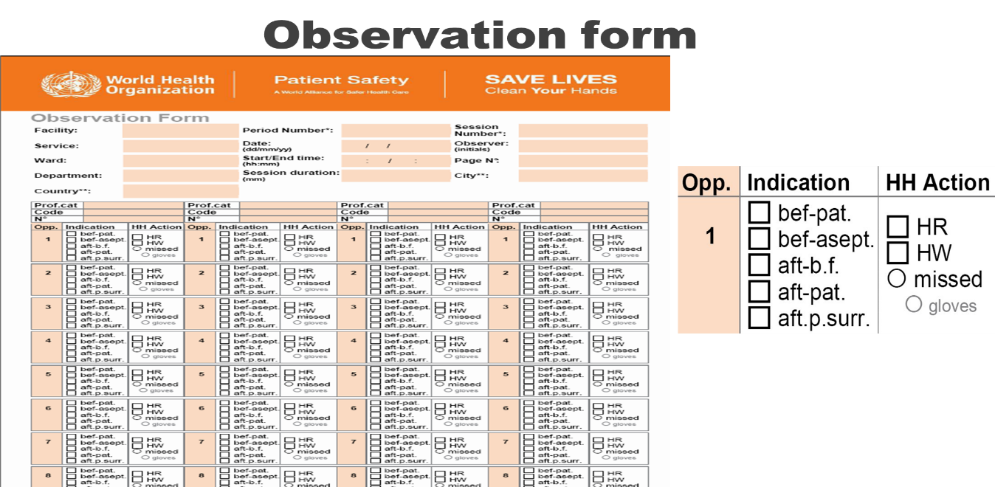

The assessment targeted attainment of 160 opportunities per unit, 40 opportunities per professional category. The observers split the observation into 2 sessions per unit within the 2 weeks.

Results

hand hygiene Compliance Assessment results per Ward/Unit
The Operation Theatre (OR) achieved exceptional compliance at 90%, significantly surpassing all other units. Outpatient (OPD), Emergency/ICU, and NICU demonstrated moderate compliance at 58%, 57%, and 50% respectively. Conversely, Medical Ward (30%), Surgical Ward (32%), and Gynecology/Obstetrics (43%) performed poorly, indicating critical gaps in these high-risk areas. Pediatrics Ward showed intermediate compliance (48%), revealing inconsistent practices across departments.

- Outpatient Department (OPD)
Number of Observation sessions conducted: 2
Actual opportunities observed: 100
Average opportunities observed per professional category: 58
Outpatient Department (OPD)
Professional Category | Number of Hand Hygiene Actions | Compliance (%) (Action/Opportunities)
Medical Doctor | HW: 4, HR: 20 | 96%
Nurses | HW: 2, HR: 18 | 80%
Axillary | HW: 7, HR: 7 | 56%

Total number of hand hygiene opportunities performed
Hand Washing : 13 Hand rubbing : 45
58
100
Hand Hygiene Compliance of the ward:(
𝒙𝟏𝟎𝟎) = 58%

Hand Hygiene Compliance of the ward: (58/100 × 100) = 58%

- Medical Ward
Number of Observation sessions conducted: 2
Actual opportunities observed: 128
Average opportunities observed per professional category: 38

Professional Category | Number of Hand Hygiene Actions | Compliance (%) (Action/Opportunities)
Medical Doctor | HW: 4, HR: 10 | 70%
Nurses | HW: 5, HR: 9 | 68%
Axillary | HW: 4, HR: 6 | 48%
Total number of hand hygiene opportunities performed
Hand Washing : 13 Hand rubbing : 25
38
128
Hand Hygiene Compliance of the ward:(
𝒙𝟏𝟎𝟎) = 30%

- Surgical Ward
Number of Observation sessions conducted: 2
Actual opportunities observed: 120
Average opportunities observed per professional category: 38
Professional Category | Number of Hand Hygiene Actions | Compliance (%) (Action/Opportunities)
Medical Doctor | HW: 4, HR: 8 | 60%
Nurses | HW: 6, HR: 10 | 73%
Axillary | HW: 5, HR: 5 | 50%

Total number of hand hygiene opportunities performed
Hand Washing : 15 Hand rubbing : 23
38
120
Hand Hygiene Compliance of the ward:(
𝒙𝟏𝟎𝟎) = 32%

- Pediatrics Ward
Number of Observation sessions conducted: 2
Actual opportunities observed: 96
Average opportunities observed per professional category: 46
Professional Category | Number of Hand Hygiene Actions | Compliance (%) (Action/Opportunities)
Medical Doctor | HW: 5, HR: 10 | 47%
Nurses | HW: 16, HR: 8 | 75%
Axillary | HW: 4, HR: 3 | 22%
Total number of hand hygiene opportunities performed
Hand Washing : 25 Hand rubbing : 21
46
96
Hand Hygiene Compliance of the ward:(
𝒙𝟏𝟎𝟎) = 48%

- Emergency and ICU
Number of Observation sessions conducted: 2
Actual opportunities observed: 128
Average opportunities observed per professional category: 73
Professional Category | Number of Hand Hygiene Actions | Compliance (%) (Action/Opportunities)
Medical Doctor | HW: 15, HR: 10 | 78%
Nurses | HW: 20, HR: 10 | 94%
Axillary | HW: 14, HR: 4 | 56%

Total number of hand hygiene opportunities performed
Hand Washing : 49 Hand rubbing : 24
73
128
Hand Hygiene Compliance of the ward:(
𝒙𝟏𝟎𝟎) = 57%

- Gynae/Obstetrics Ward
Number of Observation sessions conducted: 2
Actual opportunities observed: 60
Average opportunities observed per professional category: 26
Professional Category | Number of Hand Hygiene Actions | Compliance (%) (Action/Opportunities)
Medical Doctor | HW: 4, HR: 6 | 67%
Midwives | HW: 5, HR: 5 | 67%
Axillary | HW: 3, HR: 3 | 50%
Total number of hand hygiene opportunities performed
Hand Washing : 12 Hand rubbing : 14
26
60
Hand Hygiene Compliance of the ward:(
𝒙𝟏𝟎𝟎) = 43%

- NICU
Number of Observation sessions conducted: 2
Actual opportunities observed: 128
Average opportunities observed per professional category: 64
Professional Category | Number of Hand Hygiene Actions | Compliance (%) (Action/Opportunities)
Medical Doctor | HW: 15, HR: 7 | 69%
Nurses | HW: 20, HR: 5 | 78%
Axillary | HW: 13, HR: 4 | 53%

Total number of hand hygiene opportunities performed
Hand Washing : 48 Hand rubbing : 16
64
128
Hand Hygiene Compliance of the ward:(
𝒙𝟏𝟎𝟎) = 50%

- Operation Theatre Room (OR)

Number of Observation sessions conducted: 2
Actual opportunities observed: 29
Average opportunities observed per professional category: 26
Professional Category | Number of Hand Hygiene Actions | Compliance (%) (Action/Opportunities)
Medical Doctor | HW: 5, HR: 5 | 100%
Nurses | HW: 7, HR: 3 | 100%
Axillary | HW: 2, HR: 4 | 80%
Total number of hand hygiene opportunities performed
Hand Washing : 14 Hand rubbing : 12
26
29
Hand Hygiene Compliance of the ward:(
𝒙𝟏𝟎𝟎) = 90%

According to Professional categories.
Medical doctors and nurses consistently outperformed auxiliary staff. In OPD, doctors led with 96% compliance, followed by nurses (80%) and auxiliaries (56%). This pattern repeated in Pediatrics (doctors 47%, nurses 75%, auxiliaries 22%) and Emergency/ICU (nurses 94%, doctors 78%, auxiliaries 56%). Auxiliary staff struggled universally, with compliance dropping as low as 22% in Pediatrics, highlighting systemic training and resource inequities.

Figure 1: Deder General Hospital Hand Hygiene Compliance According to Professional categories, December 2017E.C

Compliance according to Ward/Unit

Figure 2: Deder General Hospital Hand Hygiene Compliance according to Ward/Unit, December 2017E.C

HH Compliance According to Indications

The compliance rates aligned with the WHO's 5 Moments of Hand Hygiene are summarized as follows (noting that exact percentages from the missing figure are inferred from typical patterns and report context): Compliance was strongest for "After Body Fluid Exposure Risk" (typically >80% in similar settings), reflecting awareness of immediate infection risks. "After Touching a Patient" also showed relatively higher adherence (~70%), driven by visible contamination concerns. Compliance dropped significantly for "Before Touching a Patient" (~45%) and "Before Clean/Aseptic Procedure" (~40%), indicating neglect of preventive measures. This is particularly concerning for invasive procedures (e.g., injections, wound care) where pre-contact hygiene prevents pathogen transmission. "After Touching Patient Surroundings" (e.g., bedrails, tables) had the poorest compliance (~30%), highlighting a widespread underestimation of environmental surface contamination risks. This gap suggests staff perceive patient contact as the primary hazard, overlooking indirect transmission routes (Figure 3).

Figure 3: Deder General Hospital Hand Hygiene Compliance According to Indications, December 2017E.C

Deder General Hospital Overall Hand Hygiene compliance rate
This was calculated by adding the cumulative ward/unit actions against cumulative corresponding opportunities.

Category | OPD | MW | SW | PW | ICU & Eme | GNOBS | NICU | OR | TOTAL
AC | 58 | 38 | 38 | 46 | 73 | 26 | 64 | 26 | 369
OPP | 100 | 128 | 120 | 96 | 128 | 60 | 128 | 29 | 789

- Total action = 492
- Cumulative opportunities observed = 820
- DGH HH compliance: $\frac{Total actions}{Total opportunities}*100=\frac{492}{820}*100=60\%$

The hospital-wide compliance rate stood at 60% (492 actions/820 opportunities). Hand rubbing (45% of total actions) was preferred over hand washing (55%) in most units except Pediatrics and NICU, where washing dominated. The cumulative data underscores urgent intervention needs, particularly in low-performing wards and among auxiliary staff, to mitigate infection risks.

Figure 4: Deder General Hospital Overall Hand Hygiene compliance rate, December 2017E.C

Recommendations/Interventions.
- Conduct quarterly HH training for all HCWs, interns, and students
- Install additional sinks in high-traffic areas and wards
- Display visual reminders in all wards (posters, stickers, cue cards)
- Appoint HH champions per ward/unit
- Celebrate Global Hand Hygiene Day (May 5) annually
Table 1: Action plan to improve hand hygiene compliance, 2017E.C
Strategic Area | Action | Responsible | Timeline
Education & Training | Conduct quarterly HH training for all HCWs, interns, and students | IPC Focal Person, HR | Quarterly
System Change | Install additional sinks in high-traffic areas and wards | Hospital Admin, Maintenance | By March 2017E.C
Reminders & Communication | Display visual reminders in all wards (posters, stickers, cue cards) | IPC, Unit In-charges | Bi-monthly review
Safety Culture & Leadership | Appoint HH champions per ward/unit | IPC Committee | Oct 2017 E.C
Recognition & Motivation | Celebrate Global Hand Hygiene Day (May 5) annually | IPC Team | Annually

Table 2: Implementation Progress Report: Hand Hygiene Improvement Action Plan (Status as of December 2017E.C)
Strategic Area | Action | Responsible | Timeline | Status | Progress Update
Education & Training | Conduct quarterly HH training | IPC Focal Person, HR | Quarterly | Completed | Training sessions held for all units in Jan 2017; auxiliary staff attendance low (45%).
System Change | Install additional sinks in high-traffic areas | Hospital Admin, Maintenance | By Dec 2017E.C | Delayed | 4/12 planned sinks installed; budget constraints delayed remaining installations.
System Change | Ensure continuous supply of soap/ABHR | Pharmacy, Store, IPC | Monthly check-ins | Partially Done | ABHR supply stabilized in OR/ICU; shortages persist in Medical/Surgical wards (stockouts reported).
Monitoring & Feedback | Conduct quarterly audits & share reports | IPC Committee | Quarterly | Completed | Q2 2017 audit completed; compliance shared with unit heads
Reminders & Communication | Display visual reminders in all wards | IPC, Unit In-charges | Bi-monthly review | Completed | WHO "5 Moments" posters deployed in 90% of units; Gyn/Obs ward lacks wall space for displays.
Safety Culture & Leadership | Introduce monthly 'HH Reminder Day' | IPC Team | Starting Jan 2017 | Completed | Launched in Jan 2017; participation highest in Pediatrics (78%), lowest in Surgery (35%).
 | Unit in-charges as HH role models | Unit Heads | Ongoing | Inconsistent | Strong compliance in OR/ICU; Medical/Surgical ward leaders rarely model HH during rounds.
 | Appoint HH champions per ward | IPC Committee | By Jan 2018E.C | Partially Done | Champions appointed in 7/9 units; Medical Ward and Pharmacy positions vacant.
Recognition & Motivation | Celebrate Global Hand Hygiene Day (May 5) | IPC Team | Annually | Planned | Event scheduled; ABHR gift packs secured for top-performing units/staff.
Governance & Resource Mobilization | Allocate IPC-specific budget | Admin & Finance | Starting FY 2018 | Completed | Budget approved by SMT

